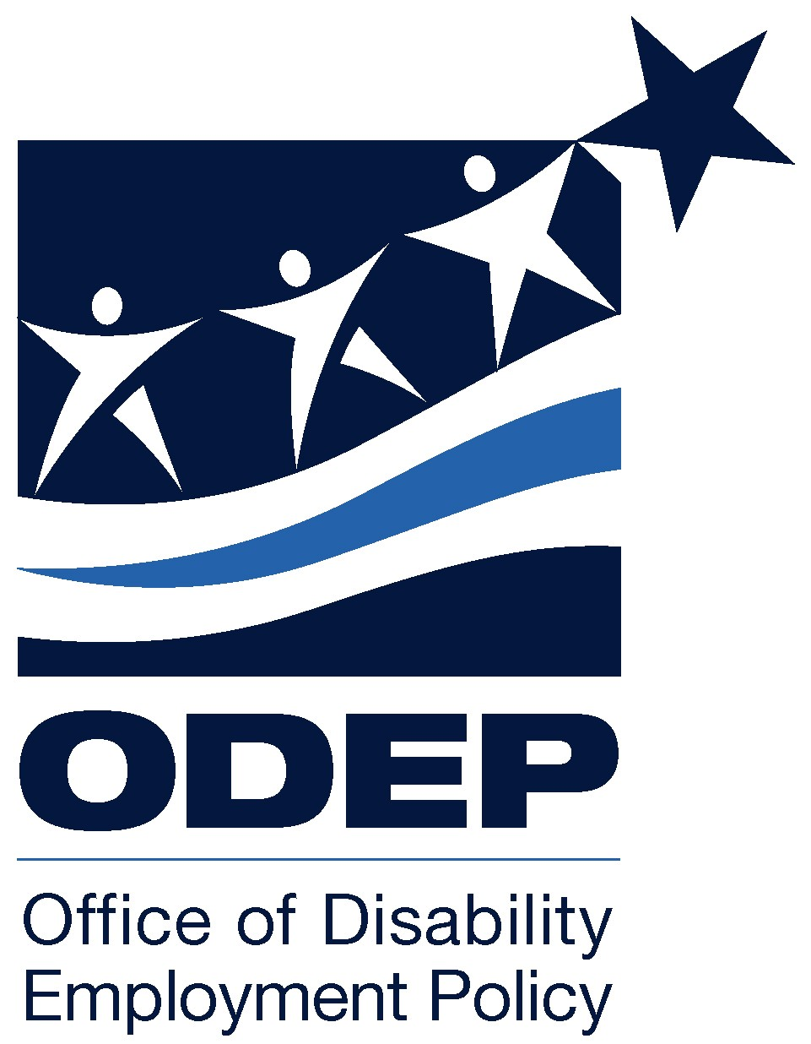

Making the Connections:

Workforce Development Systems

At-A-Glance

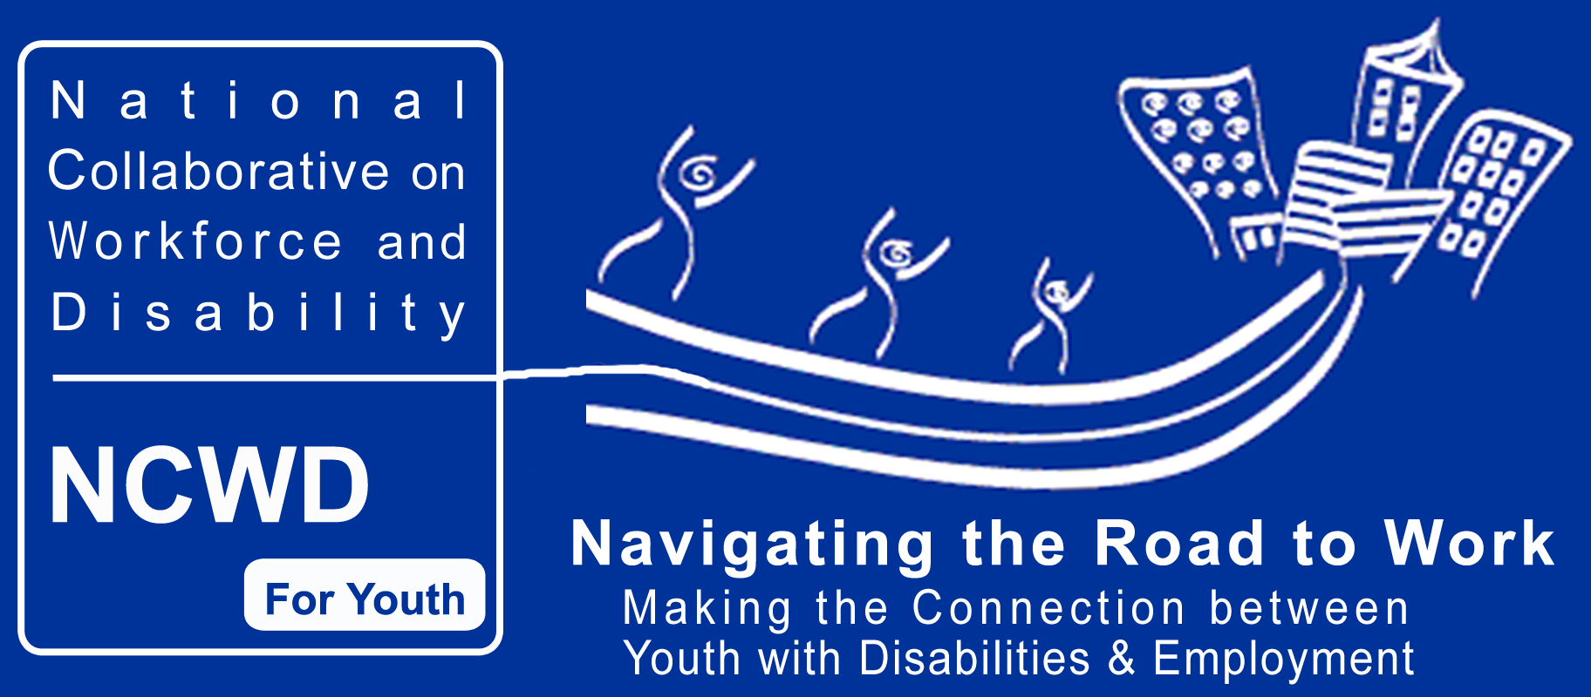

Tables Prepared by:
National Collaborative on Workforce and Disability for Youth
Under Grant #E-9-4-10070
For the
Office of Disability Employment Policy
October 2003

There continues to be a stubborn dilemma facing youth with disabilities. That is, in spite of supportive legislation and identified effective practices; these youth continue to experience high unemployment as well as insufficient opportunities to obtain competitive employment with the potential of career growth.

Just as troubling, these conditions persist in spite of the existence of educational and career development interventions known to make a positive difference in the lives of youth with disabilities. Work-based learning experiences, preferably connected to curriculum content; student-centered individualized education programs that drive instruction; family involvement in and support of education and career development activities; and linkages to individually determined support services have been proven, by both practice and research, to lead to the education and employment success of youth with disabilities. This is the case regardless of the nature of the disability or the degree of accommodation and support needed. In other words, we know what is needed and we know how to do it. And yet, post-school employment success and economic independence continue to be exasperatingly elusive for most youth with disabilities.

To what can we attribute this disconnection between, on one hand, legislative intent, stated public policies, and effective educational and career development practices, and, on the other, relentlessly disappointing educational and employment outcomes?

Critical disconnections exist between and among community institutions. The goal of improving educational and employment outcomes for youth with disabilities would be better served by focusing on the strategic and coordinated use of the resources currently available within a state’s education and workforce development systems.

A commonly agreed upon definition of what is meant by the term “workforce development system” is still evolving. This is not particularly surprising. The term was seldom used until the beginning of the 1990s, prior to the development of WIA. In the late 1980s several states initiated agency consolidations based upon their own assessment of the overlap and duplication among various state and federal government programs. The federal government responded by giving governors broader powers to oversee the growth of the workforce development system within each state.

Today a broad array of entities at the national, state, and local levels exist with diverse responsibilities for planning, funding, administering, and operating programs to assist individuals with and without disabilities to obtain education, training, job placement, and support services. Table I-A illustrates the range of such institutions and organizations that are a part of the workforce development system of which the state government has the responsibility for defining powers and responsibilities as well as key non-profit organizations that are involved in the delivery of workforce programs. Table I-B provides information about federal programs that are a part of the workforce development system.

TABLE I-A

Parts of the Workforce Development System:

A Sampling of Educational, Workforce, and Support Services Organizations
Serving Youth Ages 14 to 25

INSTITUTIONS/  ORGANIZATIONS/ | TYPE OF SERVICES | NATIONAL NUMBER
State Chartered
High Schools | Secondary education. | 21,994 secondary schools 12,197 combined secondary and elementary schools
Comprehensive High Schools | Combined academic and vocational preparation. | 15,005
Area Vocational-Technical (Voc-Tech) Centers | Preparation for specific trade and occupational areas. | 1,816
Charter and Alternative High Schools | Varies by state law in terms of role and designation of purpose. | Charter High Schools- 2,695  Alternative schools unknown
Community Colleges | 2 year associate degree programs, preparation for 4 year degree programs, specific continuing and adult education. | 1,600 (including branch campuses)
Public Four Year Colleges and Universities | Full range of degree granting programs. | 612 public institutions, 4 year or higher
Cities, County Government, and Regional Development or Service Organizations sponsored by general units of government or school districts | These local units of government often provide direct services including workforce development. | Numbers of those that are directly involved in providing workforce development services vary by state.
Local Non-Profit Organizations or Private sector-led organizations
Community Rehabilitation Programs | Employment services for people with disabilities. | 8,100
Community Based Organizations/Faith-based organizations | Employment and/or human service services, such as recreation and youth development activities.  These may or may not be a part of a national network (e.g., Boys and Girls Clubs, National Urban League, Communities in Schools, etc.). | >10,000
Private Sector-led organizations (Chambers of Commerce, industry associations, apprenticeship programs etc.) | Skill training, remediation, apprenticeships, etc. | Some 175-200 chambers and business organizations have been identified as active intermediaries though the number of chambers is much larger and many are involved in building a workforce development system
Federally Mandated Advisory and Governing Bodies
Workforce Investment Boards (WIBs) | WIBs serve as governing bodies for WIA programs, and work on state and local workforce system.  Private sector representatives hold the majority seats.  Local boards are required to have Youth Councils; state boards have options for youth councils. | 52 state  591 local
State Council on Developmental Disabilities | Governor appoints state board, which develops a state plan for services.  Consumers and representatives of state agencies responsible for oversight of services make up the Council.  The statewide services plan includes workforce preparation activities. | 57
State Rehabilitation Council | Appointed by the governor, reviews, analyzes, and advises state rehabilitation agency about goals and priorities, effectiveness, and customer satisfaction.  Annual reports to the governor and the Commissioner required. | 80
Statewide Independent Living Council | Appointed by the governor to develop, monitor, and evaluate state independent living plans. | 55 states and territories

TABLE I –B
Federally Supported

Parts of the Workforce Development System
Serving Youth Ages 14-25
Note: If an * appears it means the services are a part of the mandated One-Stop system.

AUTHORIZING ACT | TYPE OF SERVICES | AGES AND ELIGIBILITY | NATIONAL NUMBER
Department of Education
Office of Special Education and Rehabilitative Services
Rehabilitation Act of 1973, Title I | *Rehabilitation Agencies  State rehabilitation agencies responsible for statewide vocational rehabilitation programs.  Services are provided to people with disabilities based on Individualized Plan for Employment (IPE).  Transition services for youth is an allowable activity. | To be eligible for vocational rehabilitation services, an individual must: have a physical or mental impairment that results in a substantial impediment to employment; be able to benefit from receiving vocational rehabilitation services; and require vocational rehabilitation services to prepare for, secure, retain or regain employment.  Age not specified. | Combined: 32  General: 24  Blind: 24  TOTAL: 80  Note: States have the option to have just one agency responsible for blind as well as all other persons with disabilities or to have two agencies.
Rehabilitation Act of 1973, as amended, Title VII, Chapter 1, Part B | Independent Living Centers  Independent Living Centers help people with disabilities maximize opportunities to live independently in the community.  Centers can provide employment related support to individuals but actual training or education is typically not provided. | Centers set their own age requirements. | 625 total ILC’s, 336 of which are federally funded
Rehabilitation Act of 1973, as amended, Title VI, Part B | Supported Employment Programs  VR state agencies develop collaborative programs to provide supported employment services for individuals with the most significant disabilities. | Individuals with most significant disabilities.  Age not specified; for transition services, the regulations encourage agencies to work with students as early as possible. | Most of these programs are managed by non-profit community rehabilitation agencies – the estimated number is 8,100
Assistive Technology Act of 1998, sunsetting in fiscal year 2004 | Assistive Technology Centers  Centers provide information to children and adults with disabilities on increasing their use of standard, assistive, and information technologies and services. | Age not specified. | 56
Office of Vocational and Adult Education
Carl D. Perkins Vocational-Technical Education Act Amendments of 1998, Title I | *Career-Technical Education Programs  Funds can be used for a broad range of programs, services, and activities designed to improve career–technical education programs and ensure access to students who are members of populations with special needs. | Individuals in secondary and postsecondary schools.  Age not specified but generally geared toward high school and community college students. | Education provided in either comprehensive high schools (15,005) or area voc-tech centers  (1,816)
Carl D. Perkins Vocational-Technical Education Act Amendments of 1998, Title II | *Tech-Prep Programs  A sequenced program of study that combines at least two years of secondary and two years of postsecondary education.  Occupational education or an apprenticeship program of at least two years following secondary instruction. | Beginning as early as the ninth year of school and can extend through two years of postsecondary. | Roughly 47% of the nation's high schools (or 7,400 high schools) offer one or more Tech Prep programs
Workforce Investment Act of 1998, Title II | *Adult Literacy Programs  Provides basic education instruction through a variety of program settings (e.g., community colleges, high schools, alternative schools, community based organizations, One-Stops, etc.). | Over the age of 16, not currently enrolled in school, who lack a high school diploma or the basic skills to function effectively as parents, workers, and citizens. | 5,263 Literacy Programs
Individuals with Disabilities Education Act (IDEA) 1997,  Part B and Part D, Subpart 1 authorizes Program Improvement grants to states | Individualized Education Programs (IEPs)  Guaranteed right to free and appropriate education.  IEPs are individualized plans to provide education for a young person including transition from school to positive adult outcomes. | Individuals are eligible for education services up to the age of 18 or through the age of 21 at the discretion of the state.  Transitioning planning can begin at age 14 but must occur by age 16. | 1,938,000 students between 14 and 21 received IDEA services in 2000-2001 school year
Department of Health and Human Services
Administration for Children and Families
Personal Responsibility and Work Opportunity Reconciliation Act of  1996 (PRWORA)  Title I is Temporary Assistance for Needy Families (TANF) | *Required Work for Adults  Provides assistance and work opportunities to needy families by granting states the federal funds and flexibility to develop and implement their own welfare programs.  Work activities can include education and training, work experiences, and job search. | TANF serves needy families; income and asset limitations vary by state; some assistance can only go to families with minor children.  TANF regulations define minor child as an individual who has not attained 18 years of age or has not attained 19 years of age and is a full-time student in a secondary school (or in the equivalent level of vocational or technical training). | FY 2001, the average monthly number of TANF families was 2,120,500 which included 787,000 child-only cases
Developmental Disabilities Assistance and Bill of Rights Act 1996 | Support to Targeted Population  The emphasis of the State Plan is to increase the self-determination, independence, productivity, inclusion and integration into the community of people with developmental disabilities. | Services are for those who have a developmental disability.  There is no age limitation on the services provided.  Age is a factor in the diagnosis process. | Total number of programs and services centered on workforce preparation and support services unknown
Foster Care Independence Act of 1999 which enacted the John H. Chafee Foster Care Independence Program | Support to Targeted Populations  States assist youth in a successful transition to adulthood.  Activities and programs include, but are not limited to, help with education, employment, financial management, housing, emotional support and assured connections to caring adults for older youth in foster care as well as youth who have aged out of the foster care.  Older youth (18-21) can receive housing assistance if needed. | State can serve youth who are likely to remain in foster care and those who have aged out of foster care up to 21 years of age. | There were 62,000 15-17 year olds in foster care as reported in a March 2002 Census Brief to give a sense of population that is “aging out” of foster care
Community Action Agencies  Title I of the Housing and Community Development Act of 1974, as amended | *Multiple Services through Centers  Community Services Block Grants create, coordinate, and deliver a broad array of programs and services.  To assist individuals in securing and maintaining employment, community action agencies provide linkages to job training opportunities, GED preparation courses, and vocational education programs. | Programs and services are to low-income individuals. | State-administered local network composed of over 1,100 local agencies, predominantly community action agencies
Substance Abuse and Mental Health Services Administration
Children’s Health Action of 2000 Public Law 106-310; and the Public Health Services Act, as amended; Title V and several sections of that title. | Substance Abuse and Mental Health Services  Grants and cooperative agreements for substance abuse treatment and prevention as well as mental health needs of regional and national significance. | For the substance abuse (alcohol and drugs) component, treatment, prevention and support to families and children are included in eligible services.  For mental health services the regional and national significance priorities determine eligibility. | Estimated 600 grants awarded in fiscal years 2002 and 2003
Public Health Service Act, Title V, Part E, Section 561, as amended; Public Law 102-321; 42 U.S.C. 290ff. | Comprehensive Community Mental Health Services for Children with Serious Emotional Disturbances Program  The program provides grants to states and communities for the improvement and expansion of community –based systems of care for children with serious emotional disturbances and their families.  Individualized service plans dictate the range of services and can include can include non-mental health services including education, vocational counseling and rehabilitation, and protection and advocacy. | Under the age of 22. | Forty-four grants per year. Estimated nationwide 4.5-6.3 million children with serious emotional disturbances and their families
Public Health Service Act, Title XIX, Part B as amended, Public Law 1060310; 42 | Mental Health Services  Through block grants to states, a range of services can be provided through qualified community programs. Services include but are not limited to psychosocial rehabilitation programs, mental health peer-support programs and primary consumer-directed programs. | Mental health condition determines eligibility. | 59 grants
Center for Medicare and Medicaid Services
Title XIX of the Social Security Act | Insurance  Provides medical assistance through the Medicaid Program. | Individuals and families with low incomes and resources. | In FY 2003 40.4 million were enrolled, 7.7 million of whom are blind/disabled
Social Security Title XXI, as part of the Balanced Budget Act of 1997 | State Children’s Health Insurance Program (SCHIP)  Gives each state authorization to offer health insurance.  Families who earn too much to qualify for Medicaid may be able to qualify for SCHIP. | Children up to age 19 who are not already insured. | For FY 2002 there were  5,315, 229 children enrolled in SCHIP, including both separate child health programs and Medicaid expansion programs
Health Resources and Services Administration (HRSA)
Title V of the Social Security Act | Healthy and Ready to Work  Promotes a comprehensive system of family-centered, culturally competent, community-based care for children with special health care needs who are approaching adulthood and may need assistance in making the transition from pediatric to adult health care and to post-secondary education and/or employment. | Mainly covers children up to 18 years but some projects serve youth older then 18. | A range of demonstration grants have been launched since 1996; currently there are five statewide projects being supported

Housing and Urban Development Department

Office of Community Planning and Development
National Affordable Housing Act  Added through Section 164 of the Housing and Community Development Act of 1992 Title IV Subtitle D | *Youth Build Program  Youth Build grants are available to public or private nonprofit agencies, public housing authorities, state and local governments, Indian tribes, or any organization eligible to provide education and employment training. | Non-profit organizations assist high-risk youth between the ages of 16-24 to learn housing construction job skills and to complete their high school education. | 78 grants
Community Renewal Tax Relief Act of 2000 | Empowerment Zones/Enterprise Communities  Targets tax incentives, performance grants, and loans to designated low-income areas to create jobs, expand business opportunities, and support people looking for work.  Local units of governments are the eligible applicants. | EZs and ECs are based on economic characteristics of a geographic area and services are not age specified. | Currently 105 designated urban and rural EZ/EC’s
McKinney-Vento Homeless Assistance Act, reauthorized January 2002 | Emergency Shelter Grant Program  Provides homeless persons with basic shelter and essential support.  Can assist with the operational costs of the shelter facility.  Grants are to eligible jurisdictions, including states, territories, and qualified metropolitan cities and urban counties. | Age not specified. | In FY 2001, there were 366 grantees
Department of Justice
Office of Juvenile Justice and Delinquency Prevention
Juvenile Justice and Delinquency Prevention (JJDP) Act of 1974 (Pub. L. 93-415, 42 U.S.C. 5601 et seq.) and subsequent amendments | Services to Adjudicated Youth  Grants program funds collaborative, community-based delinquency prevention efforts.  Provides communities with funding and a guiding framework for developing and implementing comprehensive juvenile delinquency prevention plans. | States define the ages for adjudication purposes. | Currently 53 funded programs

AUTHORIZING ACT | TYPE OF SERVICES | AGES AND ELIGIBILITY | NATIONAL NUMBER
Department of Labor
Employment and Training Administration
Workforce Investment Act of 1998, Title I | One-Stop Centers  A system under which entities responsible for administering separate workforce investment, educational, and other human resource development programs collaborate to create a seamless system of service delivery.  Note * for mandated partners of the Centers. | Universal service at One-Stop for job search activities. For more intensive services, including training, older youth ages 18-21 may be co-enrolled as youth and adults. The next section (Youth Service Programs) provides details of eligibility. | 1,978 comprehensive One-Stop centers and 7,535 satellite offices
Workforce Investment Act of 1998, Title I, B for formula grants and Title IV Subtitle D for nationally managed programs. | *Youth Service Programs  The formula grant program services are determined by and contracted for by the WIBs.  The federal government manages the Youth Opportunity Programs, Migrant & Seasonal Farmworker and Native American programs. | Ages 14-21.  Eligible youth are low income and one or more of the following: deficient in basic literacy skills; a high school dropout; homeless; a runaway; or a foster child; pregnant or a parent; an offender; an individual who requires additional assistance to complete an educational program, or to secure and hold employment. | The numbers vary by program because local communities make decisions about how many and what type of services will be provided through formula grant funds
Workforce Investment Act of 1998, Title I, C | *Residentially-based Education and Training Programs  Job Corps is a federally administered program that provides academic and occupational training in a residential setting. | Same income and deficit eligibility criteria as for Youth Service Programs but ages range from 14-24 and there is no  upper age limit for an otherwise eligible individual with a disability. | 118 centers nationwide
The Wagner-Peyser Act as amended by the Workforce Investment Act of 1998, Title III, Subtitle A | *Employment Service Offices  Has listings of available jobs and provides a range of services to job seekers and employers. Also provides labor market information services. | The Employment Service provides universal service, available to all.  Age not specified. | Employment Services are part of all One-Stops but there are additional offices in each state.
American Competitiveness and Workforce Improvement Act of 1998, H-1B Technical Skills Training Grants | Regional and Local  Business Partnerships  Designed to help train U.S. workers in the high technology skills that the industry needs thereby reducing the need to import workers from abroad. | Organizations must partner and apply to the Department of Labor.  The grants are either issued to a business partnership or to a local workforce investment board and generally are aimed at adults. | 89 grants
Social Security Act, Section 403a, as added by Section 5001 of the Balanced Budget Act of 1997 | *Welfare-to-Work Services  State grants to provide community or work experiences, job creation, on-the-job training, job retention or support services, vocational education or job training for a maximum of 6 months, or contracted services for job readiness, job placement or post employment services. | Welfare recipients who have received benefits for at least 30 months or who are within 12 months of becoming ineligible for benefits due to a durational limit. | 189 grants to Workforce Investment Boards and community organizations have been issued in three rounds of competitions.
Trade Act of 1974, Title II, Chapter 2 | *Trade Adjustment Assistance  Assistance may include re-employment services, job search allowances, relocation allowances, funding for training, or readjustment allowances for eligible workers who have exhausted unemployment insurance or who are in training. | Workers who are significantly harmed by U.S. trade policies, i.e., by losing their jobs or having less work. Workers must apply for benefits within 12 months after being laid off or within 6 months after completing approved training. | 68,568 individuals were served from July 1, 2002 through June 30, 2003
United States Code, Title 38, Chapter 41 | *Disabled Veterans Readjustment Benefits  These benefits include job counseling, training and job placement. | Disabled veterans who are entitled to compensation or were released from active duty due to a service-related disability; spouses of persons who were totally disabled or died of a service-connected disability; or spouses of any active duty member of the Armed Forces who is missing in action, captured by hostile forces, or detained by a foreign government in the line of duty. | In Program Year 1999  428,687 veterans registered for service from the local veteran employment representatives stationed at employment service offices and one stops. Of that number, 39,986 were disabled veterans
Corporation for National and Community Service
National and Community Service Act of 1990 as amended, 42 U.S.C. 12571-12595 | Service and Conservation Corps  State and local programs that engage primarily youth and young adults in full-time community service, training and educational activities. | Youth and young adults ages 16-25; eligibility depends on source of funding and local decisions. | 118 Corps operate in multiple communities across 31 states and the District of Columbia;  In 2002 over 24,000 enrolled young people provided their communities with 18.3 million hours of service in year-round and summer programs
Social Security Administration
Ticket to Work and Work Incentives Improvement Act of 1999 | Training for Social Security Disability Eligible Individuals  Establishes approved providers called Employment Networks (ENs).  ENs can fund vocational rehabilitation, employment, or support services to help an individual go to work.  The program is being rolled out in three phases across the country with the last phase available in late 2003. | An individual must be receiving Social Security Disability Insurance (SSDI) or Supplemental Security Income (SSI) and must have a disability for which medical improvement is not expected or possible; the individual must live in a state where Tickets are available. | 1000  Employment Networks recognized as of October 2003

Resources and References

References for Tables I A and I B – In order as they appear in table

Digest of Education Statistics 2002, National Center on Education Statistics. Retrieved October 10, 2003 from http://nces.ed.gov/edstats/.

The National Charter School Directory 2003, Center for Education Reform (CER). Retrieved October 10, 2003 from http://edreform.com/charter_schools/.

American Association of Community Colleges. Retrieved October 10, 2003 from www.aacc.nche.edu/.

The Rehabilitation Engineering and Assistive Technology Society of North America (RESNA). Retrieved October 10, 2003 from www.resna.org/.

National Institute for Literacy. Retrieved October 10, 2003 from www.nifl.gov/.

U.S. Department of Education. Retrieved October 10, 2003 from http://www.ed.gov/about/reports/annual/osep/2002/appendix-a-pt1.pdf.

Administration for Children and Families, Department of Health and Human Services, 5th Annual Report to Congress. Retrieved October 10, 2003 from http://www.hhs.gov/.

Community Services Block Grant Statistical Report FY 2000. National Association for State Community Services Programs. Retrieved October 10, 2003 from http://www.ezlistings.com/MemberFiles/L1291/NASCSP2000ExeSumReport.pdf.

SAMHSA National Health Information Service, The Center for Mental Health Services. Retrieved October 10, 2003 from
http://www.mentalhealth.org/publications/allpubs/CA-0013/default.asp.

Center for Medicare and Medicaid Services. Retrieved October 10, 2003 from http://cms.hhs.gov/.

Healthy and Ready to Work National Center. Retrieved October 10, 2003 from http://www.hrtw.org/about_us/history.html.
U.S. Department of Housing and Urban Development, Homes and Communities. Retrieved October 10, 2003 from http://www.hud.gov/progdesc/youthb.cfm.

Office of Juvenile Justice and Delinquency Prevention. Retrieved October 10, 2003 from www.ojjdp.ncjrs.org/.

U.S. Department of Labor, Employment & Training Administration. Retrieved October 10, 2003 from http://www.doleta.gov/usworkforce/onestop/.

U.S. Department of Labor, Employment & Training Administration. Retrieved October 24, 2003 from http://wtw.doleta.gov/competitive/mailinglist.txt.

U.S. Department of Labor, Employment & Training Administration. Retrieved October 24, 2003 from Workforce System Results, http://www.doleta.gov/usworkforce/performance/Edition_5_6-30-03.pdf.

U.S. Department of Labor, Employment & Training Administration. Retrieved October 24, 2003 from Annual Report from http://www.dol.gov/vets/whatsnew/part1.pdf.

National Association of Service and Conservation Corps. Retrieved October 10, 2003 from www.nascc.org/.

Ticket to Work sponsored by the Social Security Administration. Retrieved October 10, 2003 from http://www.yourtickettowork.com/.

This document was developed by the National Collaborative on Workforce and Disability for Youth, funded by a grant from the U.S. Department of Labor, Office of Disability Employment Policy (Grant Number E-9-4-1-0070). The opinions expressed herein do not necessarily reflect the position or policy of the U.S. Department of Labor. Nor does mention of tradenames, commercial products, or organizations imply the endorsement by the U.S. Department of Labor. Individuals may produce any part of this document. Please credit the source and support of federal funds.

