Americans with Disabilities Act

An ADA Guide for Local Governments

Making Community Emergency Preparedness and
Response Programs Accessible to People with Disabilities
One of the most important roles of local government is to protect their citizenry from harm, including helping people prepare for and respond to emergencies. Making local government emergency preparedness and response programs accessible to people with disabilities is a critical part of this responsibility. Making these programs accessible is also required by the Americans with Disabilities Act of 1990 (ADA).
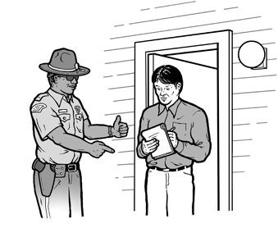  A police officer uses written notes and hand gestures to tell a man  who is deaf to evacuate. | 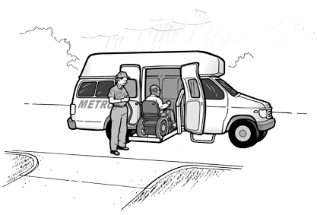  A man using a wheelchair  enters a paratransit van provided  so he can evacuate from his home. | 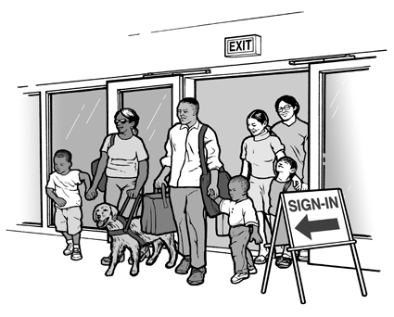  A family, including a woman  with a service animal,  arrives at a shelter.

PLANNING
If you are responsible for your community’s emergency planning or response activities, you should involve people with disabilities in identifying needs and evaluating effective emergency management practices. Issues that have the greatest impact on people with disabilities include:
• notification;
• evacuation;
• emergency transportation;
• sheltering;
• access to medications, refrigeration, and back-up power;
• access to their mobility devices or service animals while in transit or at shelters;
and
• access to information.
In planning for emergency services, you should consider the needs of people who use mobility aids such as wheelchairs, scooters, walkers, canes or crutches, or people who have limited stamina. Plans also need to include people who use oxygen or respirators, people who are blind or who have low vision, people who are deaf or hard of hearing, people who have a cognitive disability, people with mental illness, and those with other types of disabilities.
Action Step: Planning
Solicit and incorporate input from people with different types of disabilities (e.g. mobility, vision, hearing, cognitive and other disabilities) regarding all phases of your emergency management plan including:
• preparation;
• notification;
• response; and
• clean up.
NOTIFICATION
Many traditional emergency notification methods are not accessible to or usable by people with disabilities. People who are deaf or hard of hearing cannot hear radio, television, sirens, or other audible alerts. Those who are blind or who have low vision may not be aware of visual cues, such as flashing lights. Warning methods should be developed to ensure that all citizens will have the information necessary to make sound decisions and take appropriate, responsible action. Often, using a combination of methods will be more effective than relying on one method alone. For instance, combining visual and audible alerts will reach a greater audience than either method would by itself.
Action Step: Notification
Provide ways to inform people who are deaf or hard of hearing of an impending disaster if you use emergency warning systems such as sirens or other audible alerts.
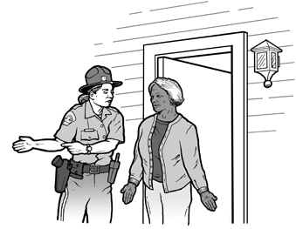
A police officer uses hand gestures
and a printed note to tell a woman who is deaf
that she needs to evacuate her home.

When the electric power supply is affected, it may be necessary to use several forms of notification. These might include the use of telephone calls, auto-dialed TTY (teletypewriter) messages, text messaging, E-mails, and even direct door-to-door contact with pre-registered individuals.
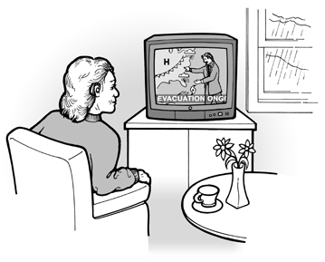
A woman who is deaf reads
a captioned evacuation notice on her television.

Also, you should consider using open-captioning on local TV stations in addition to incorporating other innovative uses of technology into such procedures, as well as lower-tech options such as dispatching qualified sign language interpreters to assist in broadcasting emergency information provided to the media.
EVACUATION
Individuals with disabilities will face a variety of challenges in evacuating, depending on the nature of the emergency. People with a mobility disability may need assistance leaving a building without a working elevator. Individuals who are blind or who have limited vision may no longer be able to independently use traditional orientation and navigation methods. An individual who is deaf may be trapped somewhere unable to communicate with anyone because the only communication device relies on voice. Procedures should be in place to ensure that people with disabilities can evacuate the physical area in a variety of conditions and with or without assistance.
Action Steps: Evacuation of People with Disabilities
Adopt policies to ensure that your community evacuation plans enable people with disabilities, including those who have mobility, vision, hearing, or cognitive disabilities, mental illness, or other disabilities, to safely self-evacuate or to be evacuated by others. Some communities are instituting voluntary, confidential registries of persons with disabilities who may need individualized evacuation assistance or notification. If you adopt or maintain such a registry, have procedures in place to ensure its voluntariness, guarantee confidentiality controls, and develop a process to update the registry. Also consider how best to publicize its availability. Whether or not a registry is used, your plan should address accessible transportation needs for people who use wheelchairs, scooters, or other mobility aids as well as people who are blind or who have low vision.
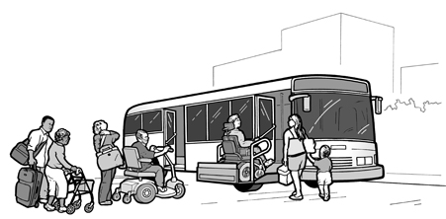
A transit bus equipped with a wheelchair lift is used to evacuate individuals and families.
Both public and private transportation may be disrupted due to overcrowding, because of blocked streets and sidewalks, or because the system is not functioning at all. The movement of people during an evacuation is critical, but many people with disabilities cannot use traditional, inaccessible transportation.
Action Steps: Evacuation with Accessible Vehicles
Identify accessible modes of transportation that may be available to help evacuate people with disabilities during an emergency. For instance, some communities have used lift-equipped school or transit buses to evacuate people who use wheelchairs during floods
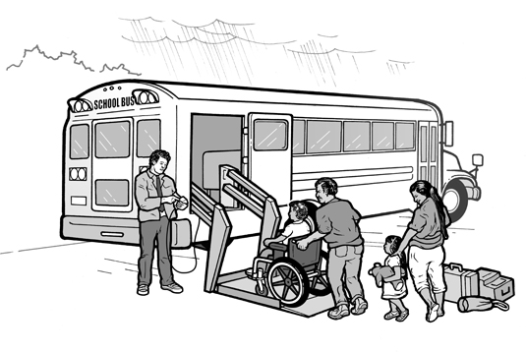
A lift-equipped school bus is used to evacuate an individual using a wheelchair and her family

SHELTERING
When disasters occur, people are often provided safe refuge in temporary shelters. Some may be located in schools, office buildings, tents, or other areas. Historically, great attention has been paid to ensuring that those shelters are well stocked with basic necessities such as food, water, and blankets. But many of these shelters have not been accessible to people with disabilities. Individuals using a wheelchair or scooter have often been able somehow to get to the shelter, only to find no accessible entrance, accessible toilet, or accessible shelter area.
Action Steps: Accessible Shelters
Survey your community’s shelters for barriers to access for persons with disabilities. For instance, if you are considering incorporating a particular high school gymnasium into your sheltering plan, early in the process you should examine its parking, the path to the gymnasium, and the toilets serving the gymnasium to make sure they are accessible to people with disabilities. If you find barriers to access, work with the facility’s owner to try to get the barriers removed. If you are unable to do so, consider another nearby facility for your community sheltering needs.
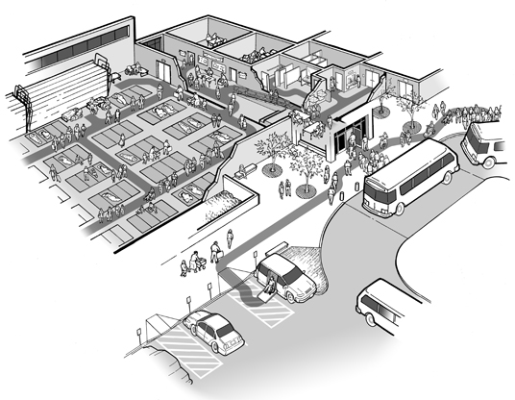
A shelter with accessible features including parking,
drop-off area, entrance, toilet rooms, and sleeping areas.
Until all of your emergency shelters have accessible parking, exterior routes, entrances, interior routes to the shelter area, and toilet rooms serving the shelter area; you should identify and widely publicize to the public, including persons with disabilities and the organizations that serve them, the locations of the most accessible emergency shelters.
Shelter staff and volunteers are often trained in first aid or other areas critical to the delivery of emergency services, but many have little, if any, familiarity with the needs of people with disabilities. In some instances, people with disabilities have been turned away from shelters because of volunteers’ lack of confidence regarding the shelter’s ability to meet their needs. Generally, people with disabilities may not be segregated or told to go to “special” shelters designated for their use. They should ordinarily be allowed to attend the same shelters as their neighbors and coworkers.
Action Steps: Input on Shelter Planning and Staff Training
Invite representatives of group homes and other people with disabilities to meet with you as part of your routine shelter planning. Discuss with them which shelters they would be more likely to use in the event of an emergency and what, if any, disability-related concerns they may have while sheltering. Develop site-specific instructions for your volunteers and staff to address these concerns.
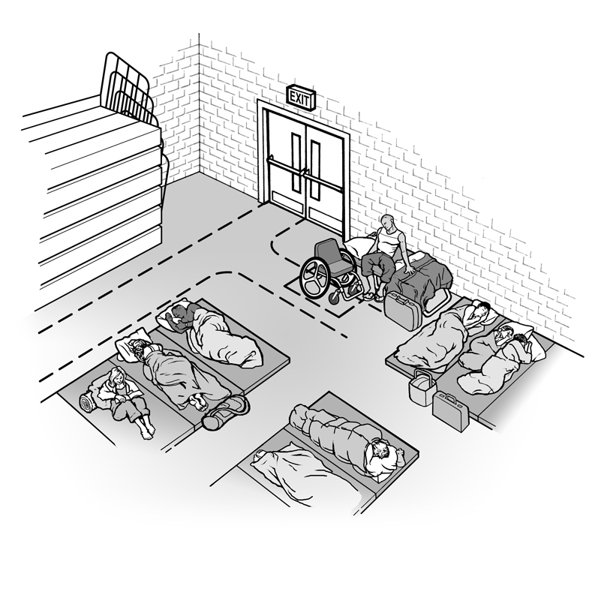
A individual who uses a wheelchair sits on a cot that is placed against a wall.
The height of the bed and the wheelchair seat are of similar height making it possible
for this person to transfer from the wheelchair to the bed.

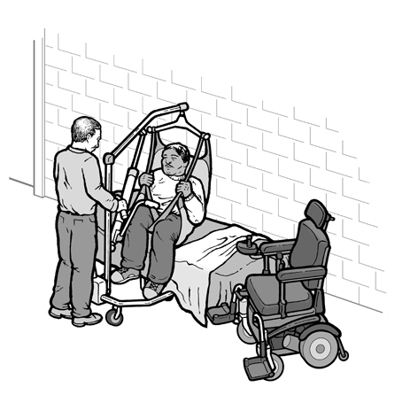  A shelter worker helps a person onto a cot using a portable lift provided by the shelter. | 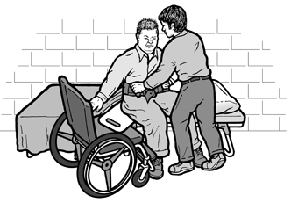  A shelter worker helps a man  transfer onto a cot.

Many shelters have a “no pets” policy and some mistakenly apply this policy to exclude service animals such as guide dogs for people who are blind, hearing dogs for people who are deaf, or dogs that pull wheelchairs or retrieve dropped objects. When people with disabilities who use service animals are told that their animals cannot enter the shelter, they are forced to choose between safety and abandoning a highly trained animal that accompanies them everywhere and allows them to function independently.
Action Steps: Service Animals
Adopt procedures to ensure that people with disabilities who use service animals are not separated from their service animals when sheltering during an emergency, even if pets are normally prohibited in shelters. While you cannot unnecessarily segregate persons who use service animals from others, you may consider the potential presence of persons who, for safety or health reasons, should not be with certain types of animals.
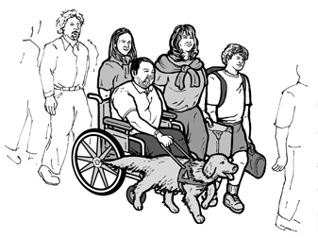
A man using a wheelchair arrives at a shelter
with his family and service animal.

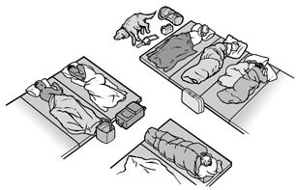
A woman has a service animal
lying on the floor next to her cot.
Individuals whose disabilities require medications, such as certain types of insulin that require constant refrigeration, may find that many shelters do not provide refrigerators or ice-packed coolers. Individuals who use life support systems and other devices rely on electricity to function and stay alive and, in many cases, may not have access to a generator or other source of electricity within a shelter.
Action Steps: Medications, Refrigeration, and Back-up Power
Ensure that a reasonable number of emergency shelters have back-up generators and a way to keep medications refrigerated (such as a refrigerator or a cooler with ice). These shelters should be made available on a priority basis to people whose disabilities require access to electricity and refrigeration, for example, for using life-sustaining medical devices, providing power to motorized wheelchairs, and preserving certain medications, such as insulin, that require refrigeration. The public should be routinely notified about the location of these shelters. In addition, if you choose to maintain a confidential registry of individuals needing transportation assistance, this registry could also record those who would be in need of particular medications. This will facilitate your planning priorities
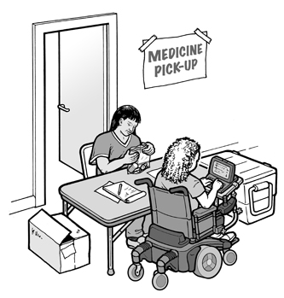
A person using a wheelchair
picks up medication at the shelter.
People who are deaf or hard of hearing may not have access to audible information routinely made available to people in the temporary shelters. Individuals who are blind or who have low vision will not be able to use printed notices, advisories, or other written information.
Action Steps: Communications
Adopt procedures to provide accessible communication for people who are deaf or hard of hearing and for people with severe speech disabilities. Train staff on the basic procedures for providing accessible communication, including exchanging notes or posting written announcements to go with spoken announcements. Train staff to read printed information, upon request, to persons who are blind or who have low vision.
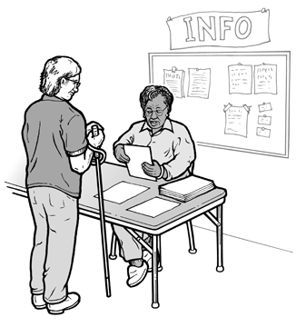
A shelter worker reads printed information
to a woman who is blind.

RETURNING HOME
The needs of individuals with disabilities should be considered, too, when they leave a shelter or are otherwise allowed to return to their home. If a ramp has been destroyed, an individual with a mobility impairment will be unable to get into and out of the house. In case temporary housing is needed past the stay at the shelter, your emergency response plan could identify available physically accessible short-term housing, as well as housing with appropriate communication devices, such as TTY’s, to ensure individuals with communication disabilities can communicate with family, friends, and medical professionals.
Action Steps: Planning
Identify temporary accessible housing (such as accessible hotel rooms within the community or in nearby communities) that could be used if people with disabilities cannot immediately return home after a disaster if, for instance, necessary accessible features such as ramps or electrical systems have been damaged.
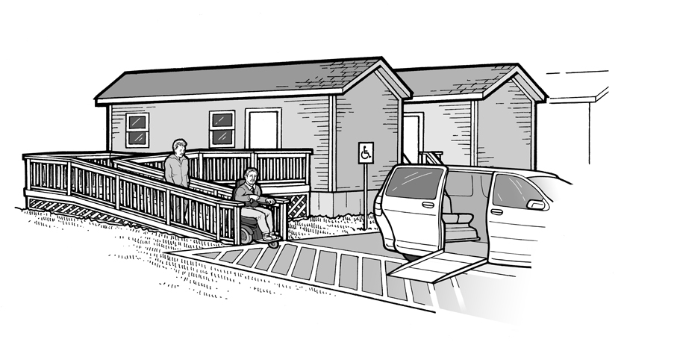
A portable trailer provides temporary accessible housing for an individual
who uses a wheelchair and his family. In addition to accessible features inside,
the trailer also has an accessible entrance, accessible parking, and the trailer
is located on an accessible route to other site features in the mobile home park.

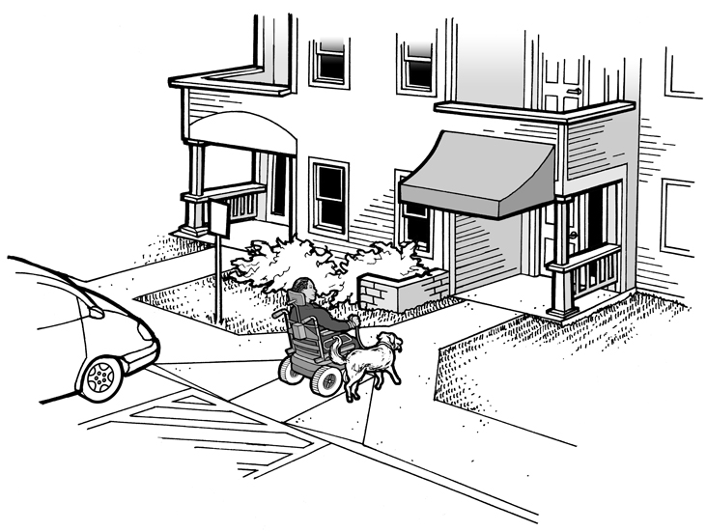
A man using a wheelchair and his service animal enters
temporary accessible housing provided in an apartment building.

CONTRACTING FOR EMERGENCY SERVICES
Many local governments provide emergency services through contracts with other local governments or private relief organizations. These entities may not fully understand the role they need to play in meeting your obligation to provide accessible emergency services.
Action Steps: Contracting for Emergency Services
Make sure that contracts for emergency services require providers to follow appropriate steps outlined in this document. Review the terms of these contracts on a regular basis to ensure that they continue to meet the accessibility needs of people with disabilities. Provide training to contractors so that they understand how best to coordinate their activities with your overall accessibility plan for emergency services.

